Node.js, Backend, and MERN Stack Overview

What is Backend?
Backend is the behind-the-scenes part of a website or application. It handles data, logic, servers, and everything the user cannot see. It ensures the website works properly.

Simple Example: When you enter login details, the backend checks them.

  - Stores and manages data.
  - Checks login and signup information.
  - Connects to databases.
  - Runs server-side logic.
  - Sends responses to the frontend.

Analogy: Frontend is the restaurant menu you see. Backend is the kitchen where food is prepared.

Backend in MERN Stack
In the MERN stack, the backend is built using Node.js and Express.js. It processes requests from React, interacts with MongoDB, and sends responses back.

  - Node.js – Runs JavaScript on the server.
  - Express.js – Helps build APIs and manage routes.
  - Handles login, signup, and authentication.
  - Validates user input.
  - Sends and retrieves data from MongoDB.
  - Manages JWT tokens, sessions, and password hashing.

Simple MERN Backend Flow:
  - User fills form → React (Frontend)
  - React sends data → Express API (Backend)
  - Backend saves data → MongoDB
  - Backend sends response → React
  - React shows message to user

What is Node.js?

Node.js is a JavaScript runtime environment that allows JavaScript to run on the server. It is built on Chrome’s V8 engine and is event-driven, non-blocking, and asynchronous. Node.js is used to build scalable web applications, APIs, and real-time apps.

Roles of Node.js and Express.js
  - Node.js: Listens for requests, runs server logic, interacts with databases, and sends responses.
  - Express.js: Handles routing, middleware, and response formatting, simplifying Node.js development.

Expanded Request-to-Response Flow
The diagram below shows the detailed flow of a request from client to server, highlighting the roles of Node.js and Express.js:

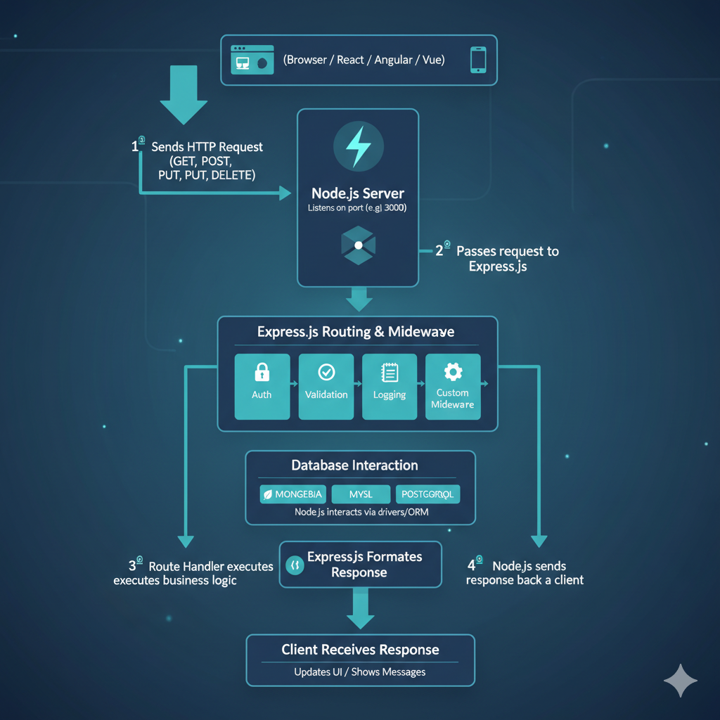

Component | Role in Flow
Node.js | Listens for requests- Handles server events asynchronously- Connects to database- Runs backend logic
Express.js | Routes requests to correct handler- Applies middleware for validation/auth/logging- Formats responses- Makes Node.js development easier
Database | Stores and retrieves data as requested by Node.js/Express- Examples: MongoDB, MySQL, PostgreSQL
Client | Sends requests- Receives responses- Updates UI dynamically- Examples: React, Angular, Vue

5.Step-by-Step Flow with Roles
- Client Request: User fills form or clicks button → Frontend sends request (React/Axios/Fetch).
- Node.js Server Receives: Node.js listens on server port and receives request asynchronously.
- Express.js Routes: Express determines which route the request belongs to (/login, /add-post, etc.).
- Middleware Runs: Express applies middleware (auth, validation, logging).
- Business Logic Execution: Node.js executes backend logic like calculations or processing data.
- Database Interaction: Node.js interacts with MongoDB/MySQL/PostgreSQL to fetch/store data.
- Response Formatting: Express prepares response (JSON/HTML).
- Response Sent: Node.js sends the response back to client.
- Frontend Updates: Client receives response → updates UI or shows message.

Summary
  - Backend is the hidden part of an application that handles data and logic.
• In MERN stack, Node.js is the runtime environment, and Express.js handles routing and middleware.
• Node.js listens for requests, executes business logic, interacts with databases, and sends responses.
• Express.js simplifies backend development by handling routing, middleware, and formatting responses.
• The frontend (React/Angular/Vue) interacts with the backend via HTTP requests and receives data in return.

